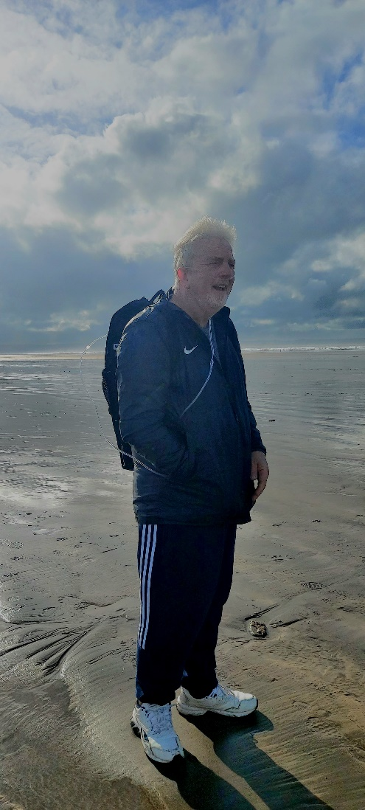
Hello,
My name is Kaylee Haskins, I want to introduce to you my Dad – he has been diagnosed with a terminal disease of Idiopathic Pulmonary Fibrosis. His prognosis is 3-5 years and he is currently in his 4th year of having the disease. He is now on Oxygen for 24 hours a day.
My Dad has become a shell of the man he was before he was diagnosed with this horrible disease. Growing up my Dad was always a strong figure in my life, always working hard, confident, enjoyed hobbies and socialising and loved life, especially with his family and friends. He was a great model of how to live life to its fullest.
Since being diagnosed in 2019 with IPF, my Dad has deteriorated into someone I hardly recognise. He has lost his appetite for life and it feels some days that he has already given up on the life he has left. Dad can no longer go on the long walks he used too with my mum, instead he prefers to sit in his chair as even slight exercise or movement causes him to get out of breath. He is unable to go on holidays anymore. Both him and my Mum were partial to a cruise, however he no longer has the mobility or strength to lift luggage into the car, let alone travel on holiday and complete activities that you would whilst you were there. He has no will to even leave the house, a holiday away together is now a far off dream.
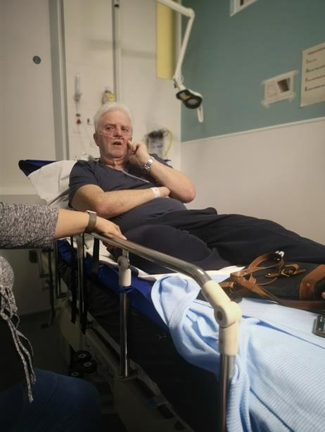
Dad has always been about his family and lives for when we can all be together and I believe this is what keeps him going even when this disease has taken so much from him already. However his experience with his family is now very different. He was always the leader of our family, the strong one that looked out for us all, however he is now being cared for fully by my mum with support from both me and my brother, which is not what he imagined for himself in later life. He has 3 beautiful grandchildren that before this disease, he would have been playing football and watching football with them, taking them to the park and walking along the beach with them – now he is unable to follow his granddaughter around when she is exploring the garden and can no longer attend his grandsons football games, which he loved to watch and support. I know this breaks his heart as he wants to be there for us all, his mind is willing, but IPF has ensured it means his body is not.
My Dad throughout his life has been extremely independent and has rarely relied on others. Since having IPF he has lost his independence and is unable to do day to day tasks that to others would be simple. He is unable to go to the toilet without getting out of breath, brush his teeth, shower and clean himself without being supported, make a cup of tea, check the garden and drive himself anywhere. He is unable to comb his hair without help, shave himself, sort out his own tablets for each day or make himself something to eat. Being unable to do any of these things have taken away the dignity my Dad held in regards to himself. He wishes to be a person that can provide for himself, my Mum and his family, however his IPF has ensured he is unable to do this.
Having IPF has changed my Dad’s life.
I am organising a quiz to help raise money for the Pulmonary Fibrosis trust to help other families going through what we have as a family. I currently feel very out of control and useless for not being able to do anything to help my Dad and so therefore what to put my mind to something in these challenging and hard times. I support him and my Mum as best as I can, but find this disease very challenging, as I know he will only get worse and does not have the chance of getting better.

