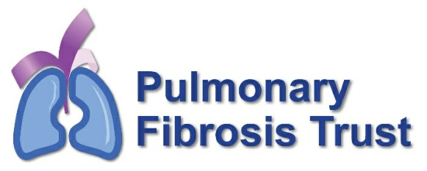

Charity Manager Position

Idiopathic pulmonary fibrosis (IPF) is a condition in which the lungs become scarred and breathing becomes increasingly difficult. Scar tissue or fibrosis in the lungs impairs how well the alveoli can transfer oxygen that is breathed in, eventually leading to low oxygen levels in the blood. As the amount of scar tissue increases, the lungs become smaller. There is currently no known cause.

The Pulmonary Fibrosis Trust was founded in 2012 by patients who experienced a lack of information and support upon their own diagnosis, and therefore, wanted to help others through this process. The charity supports all those affected by this debilitating and life-limiting condition, whether you are a sufferer or have a loved one with pulmonary fibrosis.

We offer practical, emotional and financial support, where there is a need. We also raise awareness of the illness and in particular the challenges people face on a daily basis.

We’re looking for a new Charity Manager to run the organisation on a day-to-day basis, taking care of fundraising, campaigning and the management of our small but excellent team of volunteers. If you are looking to make a real difference in your role, and you have experience of fundraising and people management in a charity, we’d love to hear from you.

Main duties and responsibilities

- Direct and lead the delivery of our strategic aims of increasing revenue and raising awareness of pulmonary fibrosis.
- Coordinate our fundraising activities including identifying and applying for suitable funding opportunities.
- Budget management, ensuring that finances are being utilised in the best way for the charity.
- Take responsibility for inspiring, engaging and managing our volunteers.
- Ensure that all volunteers are given the information, training and support, including regular supervision, that they need, to enable them to perform their roles to the best of their abilities.
- Take responsibility for the charity’s policies, updating them in line with external changes and developments.

We have a board of 10 trustees at present, some of whom have been with us since we began. As our Charity Manager, you’ll be reporting to our Chair of Trustees, with additional help, support and engagement from other members of the Board.

We also work closely with a business support company, who manage our day-to-day administrative tasks, including answering calls, liaising with patients and their families, providing social media and website support.

Key experience / skills required

- Management experience, preferably in a voluntary sector or health or social care organisation.
- You must have experience of people management and are comfortable developing relationships with a diverse range of people. From grant funders to local politicians (councillors and MPs), with trustees and volunteers, and the general public.
- Knowledge and understanding of working with vulnerable adults including those that are dealing with end-of-life care.
- Experience of national fundraising, ideally community fundraising and Trusts and Foundations, with good financial acumen.
- You need to have exceptional organisational skills and the ability to work effectively without constant supervision.
- Ideally, you’ll have a genuine interest in the issues affecting people living with pulmonary fibrosis, but this isn’t essential.
- Proficient IT skills, including all aspects of Microsoft Office, relevant packages and knowledge of database management, also an understanding of Wordpress Content Management.

Hours and location

The Pulmonary Fibrosis Trust are open to flexibility around the precise working pattern of the role, in terms of hours. The position is working from home with occasional travel.
The role is offered as a part-time role (16 hours per week), which may increase over time.

Salary and benefits

The annual full-time salary for this role is £30,000, this is part-time so pro-rata is £12,000. We offer 11 days holiday per annum (plus public holidays).

How to apply

Please send a CV and a covering letter to helen.blacker@pulmonaryfibrosistrust.org detailing why you are interested in the role of Charity Manager at the Pulmonary Fibrosis Trust and why you feel you would be the right person to lead our organisation.

